Duc Phu Pham

Prof. William Elkins

Composition II

**Visual Argument 2nd draft**

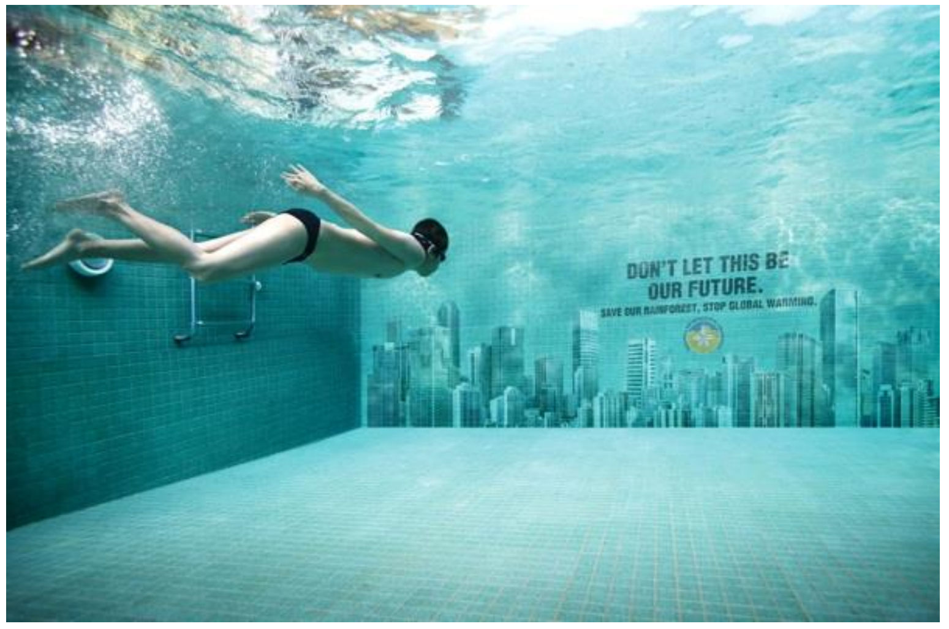

The image above is meant as an argument. The artist is trying to warn the reader of the impending doom of a future that human will have to face if they do not save the rainforest and slow down the rate of global warming.

In the image, you can see a young boy swimming underneath the water of a swimming pool and the wall in front of him has image of high rises building, for which can be seen being submerged in water with a line of text right above it that write “Don’t let this be our future. Save our rainforest, stop global warming.”. The artist cleverly use the ordinary activity of a boy swimming in the pool to showcase a glimpse into the future of what could happen to the future of our offspring if we don’t slow down the rate of global warming, thus, a city submerged in water is a result of that. Foreseeing what could be a horrendous disaster fueled by human activities that are destroying the eco-system, the artist plead the readers to save our rainforest in hope that what we seeing in the image will not happen in the future. The added text is a critical element in this piece of visual. It provides deeper context and connection to what the artist is trying to convey through the visual, as well as leaving the reader with food for thought.

To better understand how the artist shaped their message, we shall identify each different element/symbolism and how they complement each other to help piece together a clear and thoughtful picture. At its most basic definition, symbolism indicate the use of symbols to represent ideas, objects, or relationships. Symbolism stands for more than what meet the eyes. A symbol, whether in literature, art, or object, is a vessel that represent or stands for some type of ideas that are directly influenced by each individual association, resemblance, convention, or culture. Thus, it is normal for everyone to have some level of differences in their perspective of each symbol. Since each individual upbringing heavily affect how they perceive each symbol, it is worth to mention that “many rhetoricians today would say that rhetoric deals with more than just persuasion, it is also about understanding.”(Leggett). Because of this, according to Kenneth Burke’s A Rhetoric Motives, Burke himself states that “identification” is more important for the work than persuasion. Burke suggests that whenever someone attempts to persuade, identification occurs: one party must "identify" with another. That is, the one who becomes persuaded sees that one party is like another in some way. His concept of identification works not only in relation to the self, but also refers to exterior identification.

Looking at the picture, one can conclude that the artist is trying to portray the present and the future. The present, presented through the sight of a young boy swimming carelessly underneath the water, implicating the next generation of human race that we must nurture and protect. While the sight of our could be future, is ingrained on the swimming pool wall that the boy is swimming toward. The sight of high rise building, human great creation, are being submerged in the ocean, implicating how our actions will be the sole responsible for leaving the next generation with a broken and devasted planet earth. Where human most sophisticated creation will be destroyed by our own doing, the result of killing the rainforest and ignoring signs of global warming.

The targeted audience for this piece of visual rhetoric is meant to be for every human on this planet, as the duty to protect and preserve our planet do not just fall on any specific individual, rather, it is the duty of the entire human species. The visual itself is an appeal to Pathos, it is meant to tap into our emotions by portraying the possible aftermath that was caused by our own actions against mother nature. On the other hand, the provided text is an appeal to Logos, in this case the artist uses the “if/then” strategy by arguing that this would be our future if we don’t save the rainforest and stop global warming.

In conclusion, I believe the artist did a great job in raising awareness about global warming and deliver a clear picture on what could be a possibility of our future if we do not act immediately.